Covid Relief Dashboard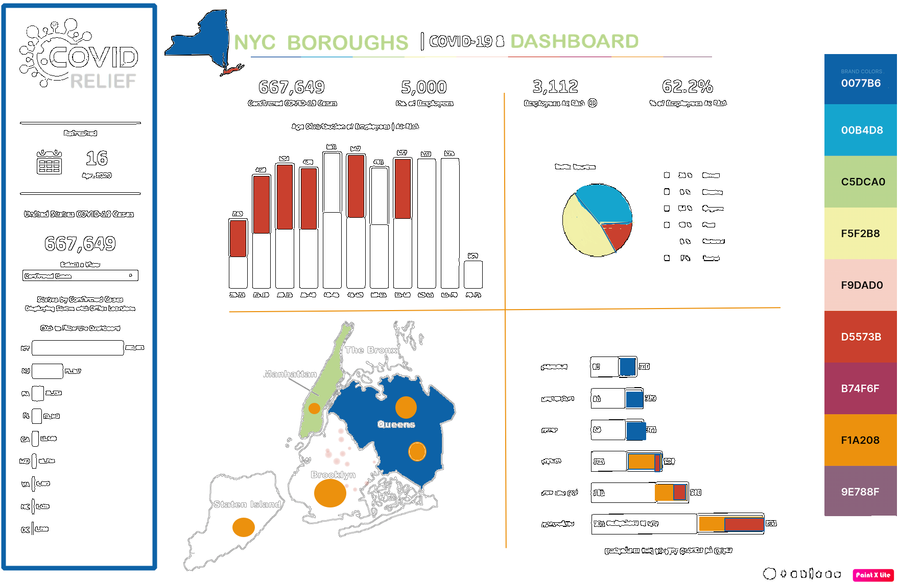

**─**

Data Group 2:

Stanislava Hristova

Clariza Mayo

Juan Peralta

Kari Sakib

# Trello Dashboard

# <https://trello.com/b/chUt7vdF/covid-19-task-checklist>

**Brand colors**

1. Background: White
2. Visualizations & Letters: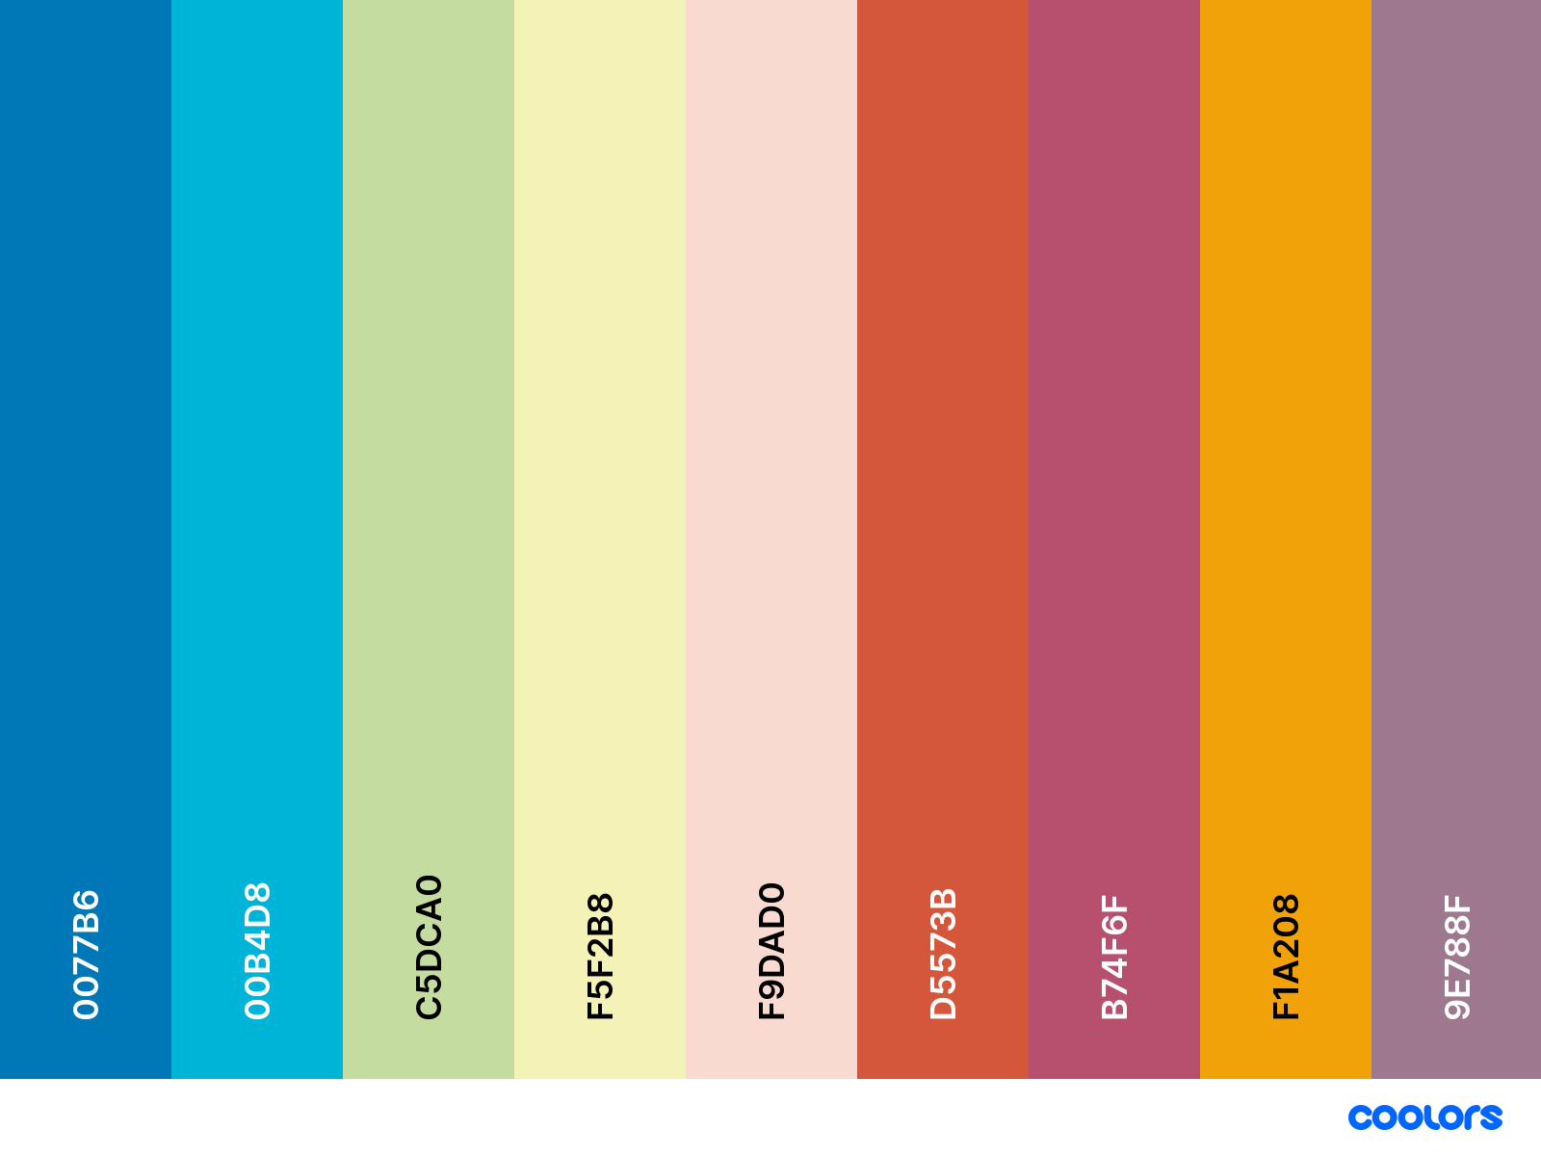

[**https://coolors.co/0077b6-00b4d8-c5dca0-f5f2b8-f9dad0-d5573b-b74f6f-f1a208-9e788f**](https://coolors.co/0077b6-00b4d8-c5dca0-f5f2b8-f9dad0-d5573b-b74f6f-f1a208-9e788f)

**Fonts:**

* Title: Saira Semi Condensed
* Text: Anaheim:

**Logo**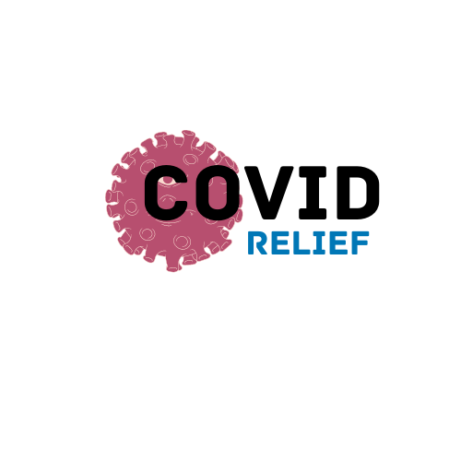

# 

# Figma Wireframe

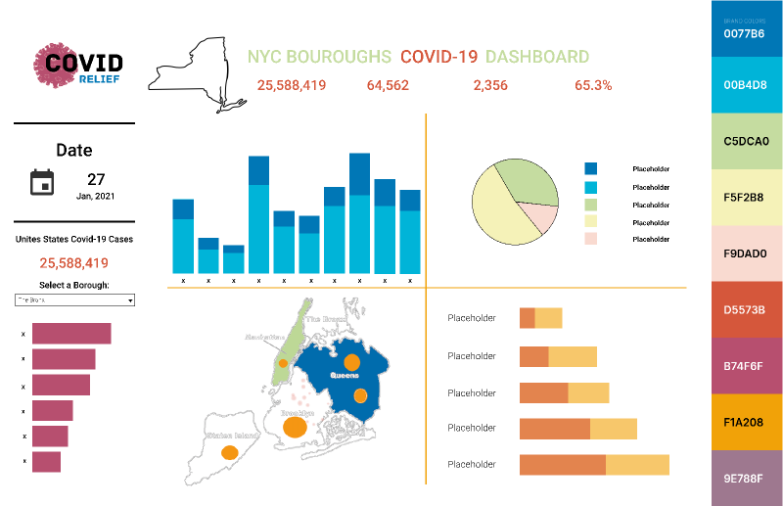

<https://www.figma.com/file/e8E9RvNInTP7KasWCQpKx3/Dashboard-First-Draft>